**Week 3 – Assignment**

**Employee Management System – Functionality 3**

Eric Vara

The University of Arizona Global Campus

CPT 200: Fundamentals of Programming Languages

Professor Amjad Alkilani

September 18, 2023

#### Purpose

The main goal of this script is to build an employee management system. It provides functionalities to continuously collect and store employee details such as name, SSN, phone number, salary, and email. It then offers users the options to either add more employee details or view all employee data stored in the system. Additionally, it tracks the total number of employees in the system and provides this information each time the system menu is displayed.

#### Variables

* employeeName, employeeSSN, employeePhone, salary, email: These variables store individual details of an employee during data input.
* employees: A list that aggregates the data of all employees. Each employee's details are appended as a sublist.
* employee_count: A global variable to keep track of the number of employees added to the system.
* choice: Stores the user's menu choice for either adding an employee, viewing all employees, or exiting the program.

#### Functions

* collect_employee_data(): A custom function designed to prompt the user for an employee's details and append them to the employees list. Also increments the global employee_count.
* view_all_employees(): This function goes through the employees list and displays all the employee data.
* main(): The main function of the script. It displays the system menu and manages user choices.
* input(): A built-in Python function utilized to collect user inputs.
* print(): A built-in Python function used to display messages and data to the console.

#### Selection

if, elif, and else within the main() function: These are utilized to handle the user's menu choice. Depending on the user's input, either a new employee's details are collected, all employees' data is displayed, or the script is terminated.

#### Repetition

A while True loop in the main() function: This is used to constantly display the system menu, enabling users to choose functionalities (like adding an employee or viewing all employees) repetitively until they decide to exit.

#### Conclusion

The script serves as a basic employee management system. It allows continuous data input for any number of employees, stores this data systematically in a master list, and offers an organized display of all collected data. Selection constructs ensure that user inputs are processed appropriately based on their menu choices. The introduction of a global counter enhances its functionality by keeping the user informed about the total number of employees in the system. Utilizing loops, the script offers repetitive access to its functionalities, providing flexibility and continuity in user interaction. While the system is functional and efficient, future iterations can incorporate features like error checks for data types, options to modify or delete employee data, and perhaps data persistence using file operations or databases.

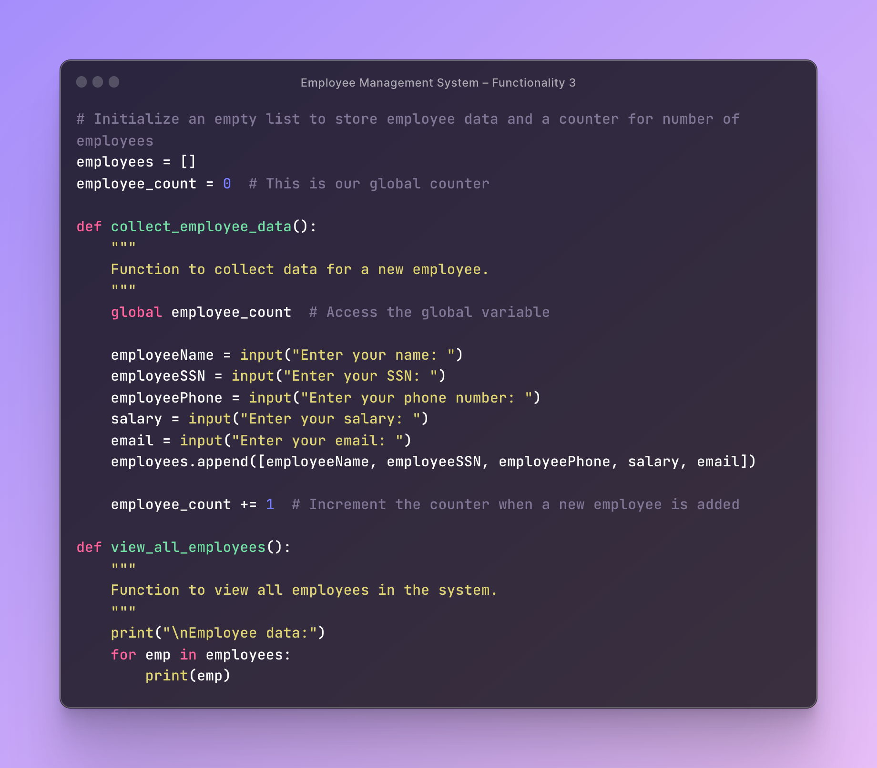

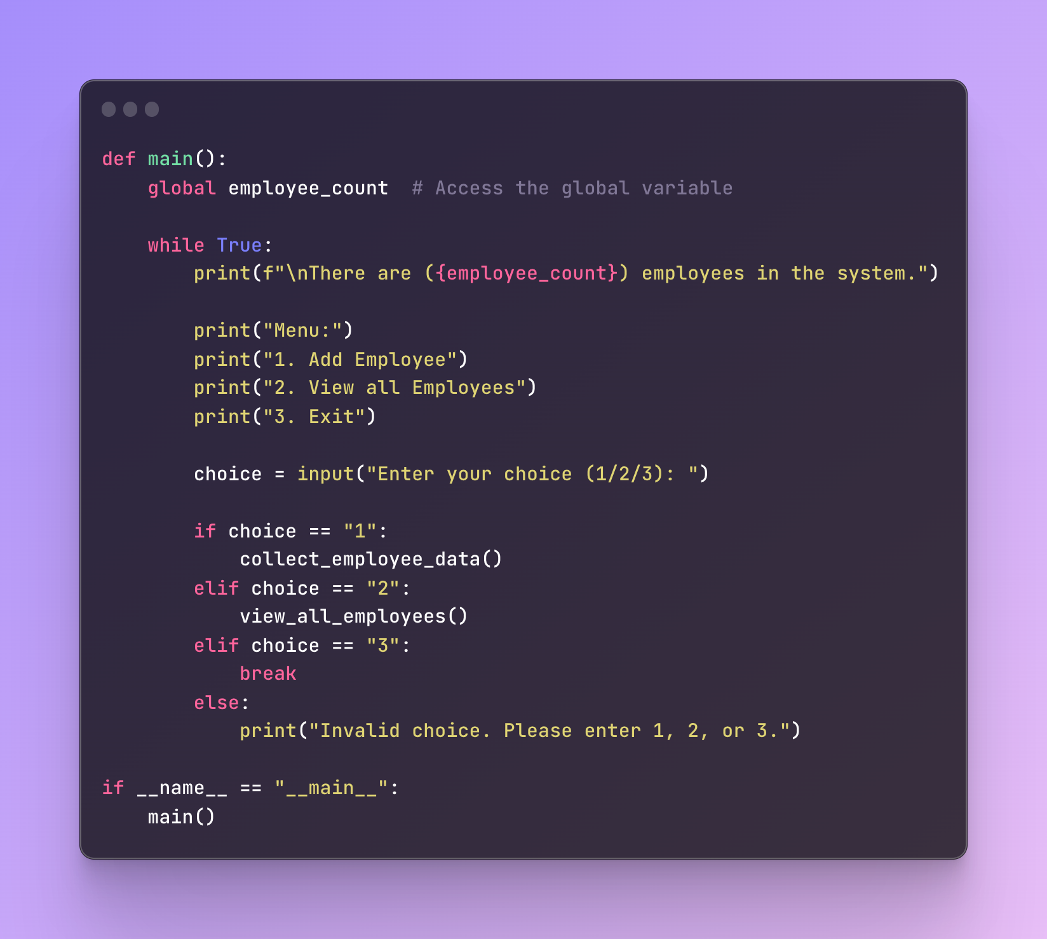

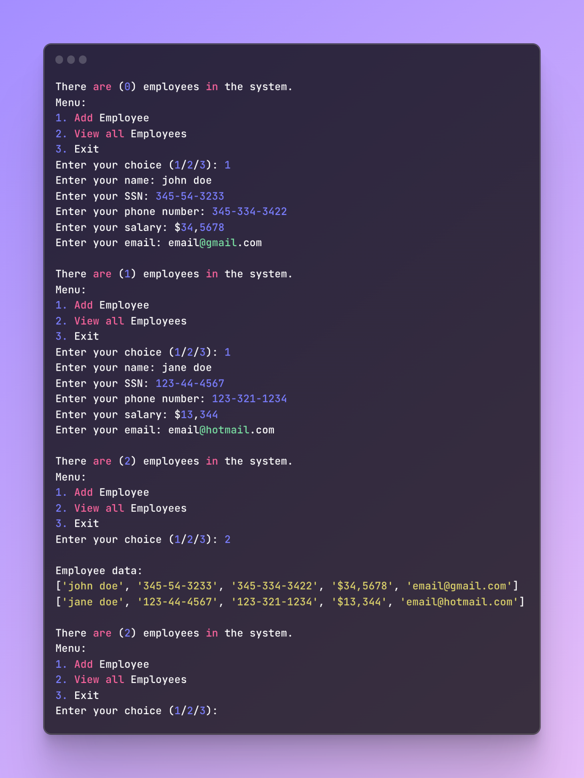

[Source Code](https://ray.so/#code=&title=)

[Console](https://ray.so/#code=&title=)